Power Supply with Current Limit Project

ECEN 350: Electronic Devices and Circuits
Author: Seth Ricks
12/13/2025

Introduction:
The final project for ECEN 350 (Electronic Devices and Circuits) was to create a power supply project with a current limit. This included calculating values for certain components, soldering a board, and analyzing the results. In this report I will discuss the design specifications, theory of operation, and the measured performance of my power supply.

Design Specifications:
The power supply in this project is designed to have either a DC or an AC powered input. My chosen output voltage for this board is 7V, so whether the board is powered with DC or AC, the output is 7V. The supply is protected against short-circuits, due to a current limit of around 153 mA, and power indicated with a red onboard LED.

Theory of Operation:
The following image (Figure 1) is the schematic for the power supply board. As you can see, there are several components and sub-circuits that make up the entire idea. First, there are diodes D1, D2, and capacitor Cf. The purpose of these components is to filter out an AC input to DC. The diodes force current to only flow in one direction, not allowing it to flow into the inputs. The diode Cf charges and smooths out the transformed DC signal while the inputs may be negative.

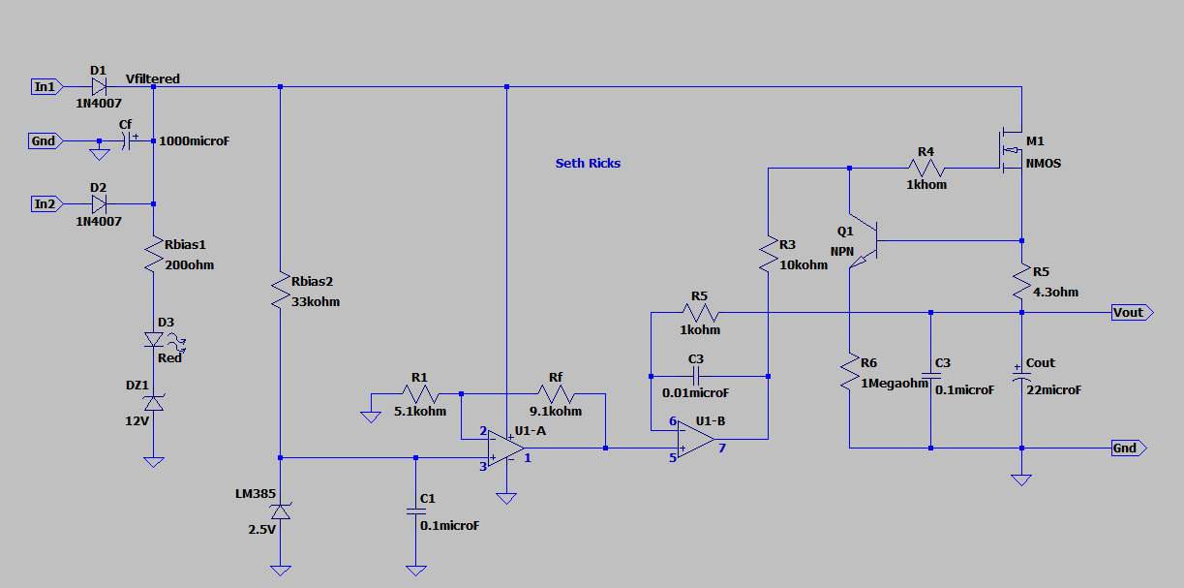
Figure 1: Schematic of 7V Power Supply with Current Limit
The next important components to note are LED D3, resistor Rbias1, and Zener diode DZ1. These components are the LED power on indicator circuit. For the light to turn on, the input voltage must be above 13.5V. This is because the Zener diode is reverse biased, with a Zener breakdown of 12V This turns into 13.5V when the Rbias1 resistor of 200 ohms is factored into the voltage drop across D3 necessary to turn on the LED. This minimum input voltage of 13.5V is as desired, as the input to the power supply is supposed to be about 14-24 volts.
There are also components such as the LM385 voltage reference Zener diode, and the U1-A op amp. The purpose of the U1-A diode is to convert a stead 2.5V to 7 Volts. The purpose of the voltage reference diode is to keep the positive terminal of the op amp at a consistent 2.5V, since it is constantly in Zener breakdown. With the combination of the chosen resistance values for R1 and Rf, the output of U1-A is 7V, the same as the design output.
The resistor R5 and transistor Q1 together create a current limit through the M1, in this case to around 153 mA. If the current through M1 approaches this limit, the NPN transistor Q1 begins to conduct. The collector of the NPN is tied to the base of the NMOS, so the more that Q1 conducts, the less the M1 base voltage. This means that current will flow through Q1 instead of M1, protecting the MOSFET from damage.
Along with MOSFET M1, the U1-B op-amp provides a regulated output voltage of the desired 7V. The voltage at Vout is supposed to be 7V, as are pins 5 and 6 on the op-amp. If the output voltage fluctuates slightly, the difference between pins 5 and 6 will increase, changing the voltage output at pin 7. This voltage will increase or decrease the base voltage of M1 slightly, allowing for a change of current through M1. This difference in conducted current results in a corrected output voltage.

Measured Performance:
After soldering the physical board, it was time to test its functionality. Table 1 below shows the measured values for the power converter board, for the corresponding parameters. These include the LED indicator minimum voltage discussed earlier, the measured current limit, the voltage ripple, and the ripple rejection ratio.

Parameter | Measured Values
Minimum DC Input Voltage that turns on the LED Indicator (V). | 13.5 V
Measured Current Limit Value I_{meas} (mA). | 160 mA
Percent error between measured and calculated current limit value, with % Error = (100)(I_{meas} – I_{calc} )/(I_{calc}). | 4.24%
Calculated input voltage ripple for I_{Load} = 0.9I_{calc}. | 1.06 V
Measured input voltage ripple (∆Vfiltered) for I_{Load} ≈ 0.9I_{calc}. (Vpk-pk). | 1.03 V
Measured output voltage for no external load. (V). | 6.91 V
Measured output voltage for I_{Load} = 0.9I_{calc}. (V) | 6.37 V
120 Hz Ripple Rejection in dB for I_{Load} = 0.9I_{calc}. | $$20\log_{10}\left(\frac{1.03V}{705μV}\right) (dB)$$  =$63.29 dB$  (Factor of 1461)
Table 1: Measured Voltage regulator Performance Parameters.
The voltage ripple was measured on an oscilloscope, which can be seen in Figure 2 below. The red trace is the voltage at Vfiltered, directly after the diodes at the input terminals. The yellow trace is the output voltage, which in this case is 7V. But because the graph is set to AC offset, it appears on the 0V line as expected.
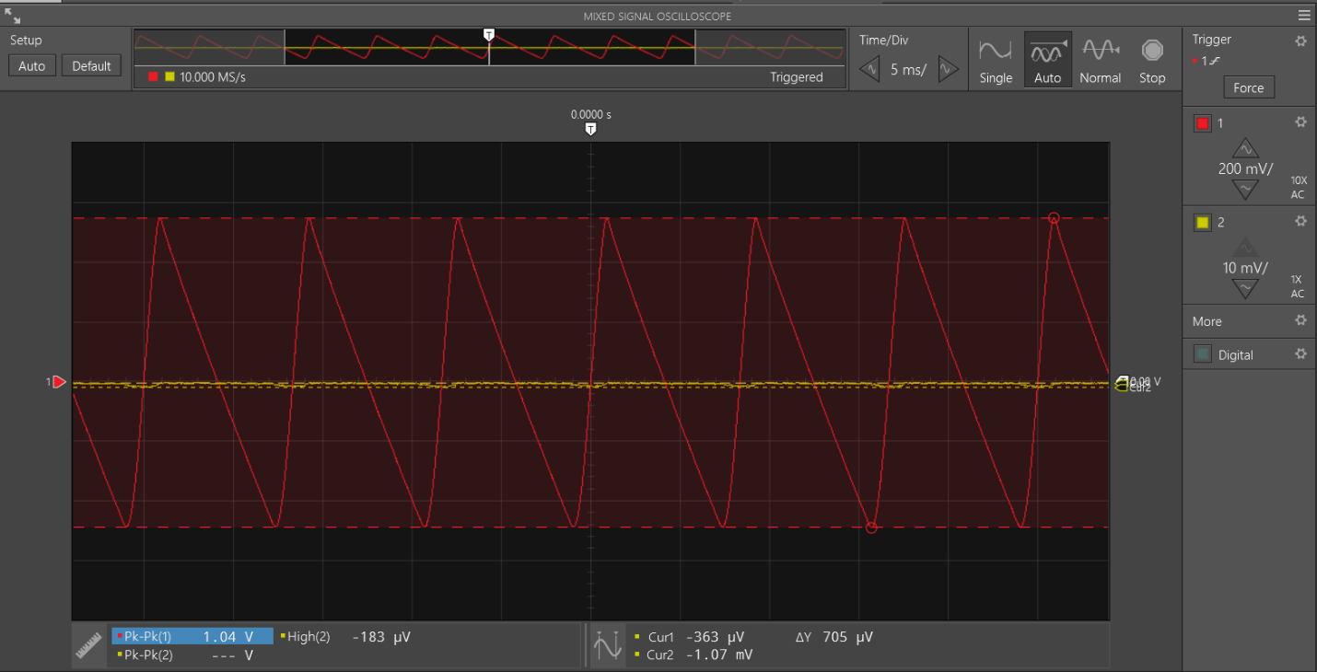
Figure 2: Output Voltage Ripple Measurement
The following graph (Figure 3) demonstrates the measured functionality of the current limiting figure discussed previously. Notice that the real-world value of the current limit isn’t exactly as calculated, but that is to be expected. The important thing is that the closer the current gets to the limit, the lower the output voltage. This is to prevent shorts on the load terminals, which would cause a rush of theoretically infinite current that would damage the power supply circuit.

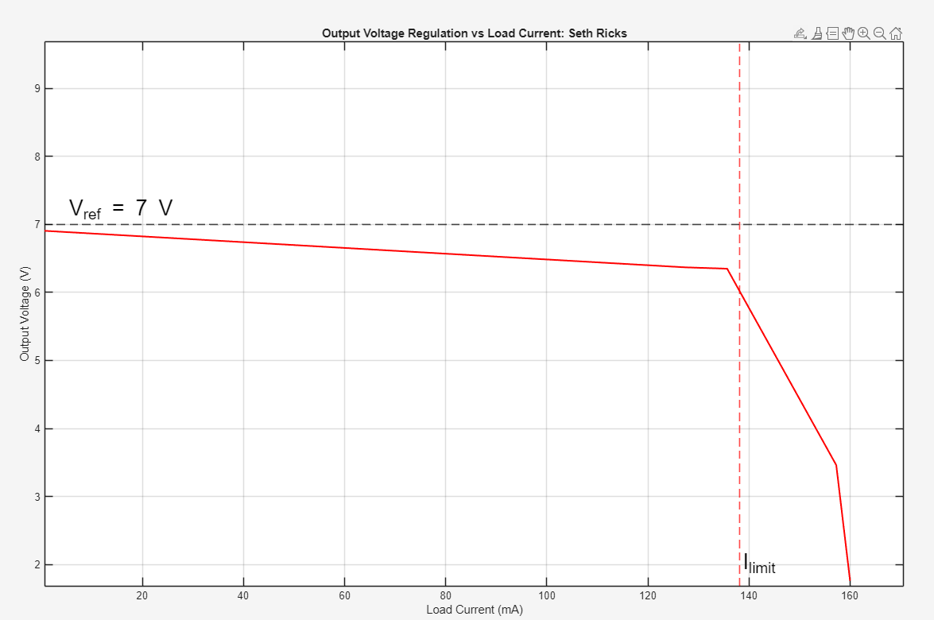
Figure 3: Output Voltage Regulation Vs Load Current

Conclusion:
The following image (Figure 4) shows the physical regulated power supply board from an above-facing view. It includes all the discussed components, along with header leads for ease of use and testing purposes.
There were quite a few challenges that I encountered in this project, mostly having to do with one fatal mistake: a backwards diode. This was a headache to fix, but in the end, I learned a lot more about how this board works. I placed one of the filtering diodes, D2, backwards. This allowed for negative current to flow, destroying several of my components including the op amp and the transistors, and other diodes. I had to replace several things, but in the process, I learned more deeply what each part does in the circuit. All in all, I learned a great deal about circuit design and testing in this lab, which allowed for growth in my understanding of electronics.

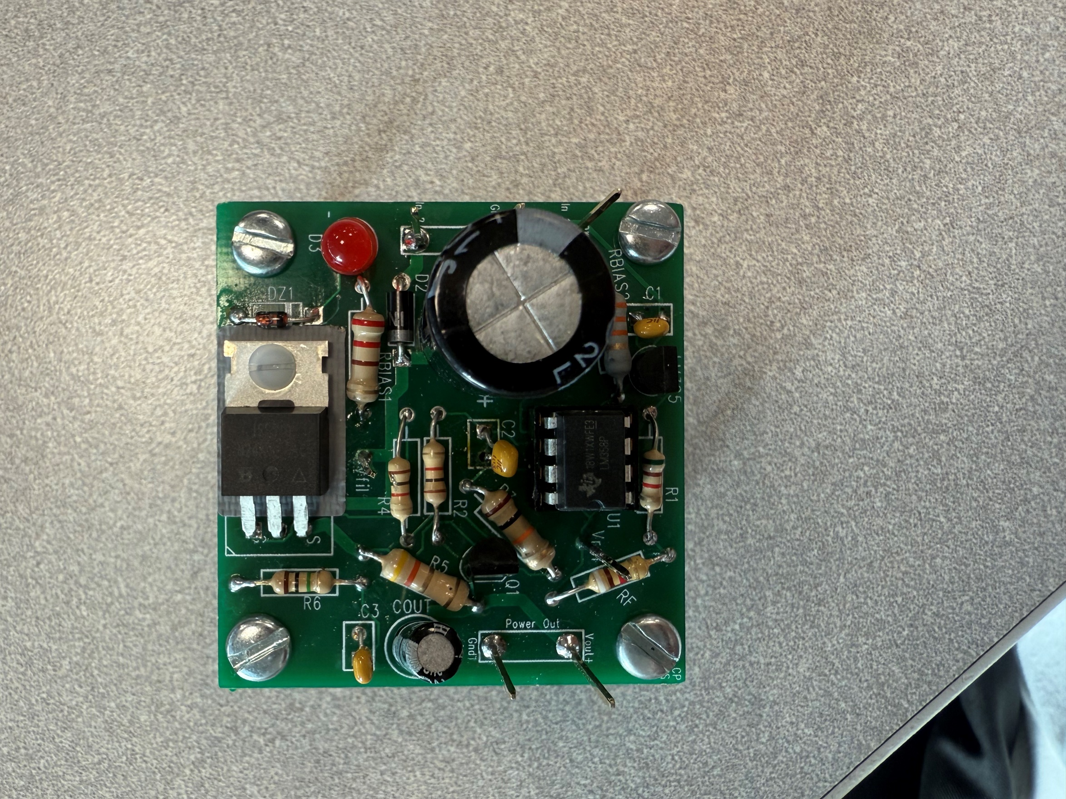
Figure 4: Completed Regulated Power Supply Board

